**Using the Tool in a distributed GenderMag Session**

What is GenderMag?

Roles, Rules and Common Errors

Roles:

Rules:

Common Errors:

How to run GenderMag with the Tool (if not distributed):

The tool in a distributed setting (testing of it)

Here’s What You Need to Set Up (if you do it on join.me):

Here’s What You Need to Set Up (if you do it on zoom):

# What is GenderMag?

GenderMag (short for Gender Inclusiveness Magnifier) is a method for finding gender-inclusiveness issues in software features. Software developers and/or user experience professionals can use it to evaluate their software products from a gender-inclusiveness lens. GenderMag does not advocate for "pink" and "blue" software, but instead gender-inclusive software.

GenderMag uses 4 personas, each based on 5 key facets of problem-solving. Research spanning approximately 10 years found that these facets contain gender differences and have informed the GenderMag personas.

GenderMag then takes these personas and incorporates them into a cognitive walkthrough. Allowing software developers and UX professionals to look at and evaluate their software through the eyes of a persona.

# Roles, Rules and Common Errors

## Roles:

***The facilitator****:* Leads the team through the walkthrough and keeps it on track. Can also help to enforce rules and prevent counterproductive work.

**The record-driver:** Records the team's comments, results in the GenderMag forms and drives the prototype for the team.

**Everyone**: does the evaluation work.

*For a distributed session, only* ***Record****-d****river*** *will have write access on the computer (Everyone can see the screen)*

## Rules:

**Stay true to the persona:** The team is looking to fix issues the persona might find, so really channel the persona.

**Follow the "ideal" sequence:** The persona might do something that is not part of the pre-made sequence but stick to the chosen sequence.

**Answer every question:** The team wants to gather as much information as they can, so don't leave anything out.

**The team doesn't have to agree:** But make sure the recorder writes down everyone’s comments.

**Just find the issues:** During the session is not the time to fix the issues, save that for after.

## Common Errors:

**"I" Methodology:** Evaluators often drift from the persona and answer questions from their perspective. Be sure to use the persona’s name to stay true to the persona.

**"Look ahead" problems:** Taking the action before the persona would, giving more information than the persona actually has.

**Confusing actions with subgoals:** Subgoals are ideas in the head while actions are done with the hands.

## Best Practices:

* Sometimes people don’t actively stay involved. To solve this, call on everyone for every question to get their response.
* There are too many windows, so keeping the persona in mind is very hard. So solve this, encourage everyone to PRINT the persona IN ADVANCE so that it’s lying in front of them and they can use their windows for all the other info they need to keep in mind.
* **Mariam might add more things.**

# How to run GenderMag with the Tool (if not distributed):

* + <http://gendermag.org/genderMag.html>

# The tool in a distributed setting (testing of it)

All participants were in a distributed location.

* Brijesh Bhuva
* Rupika Dikkala
* Mariam Guizani

**+ve :**

* We were able to finish the entire GM session in D.systerm
* Join.me easy to connect all are able to hear properly
* 2 person need to access computer
  + The facilitator will start the session
  + Record-driver willRecord and drive the project

**-ve:**

- not able to identify the cursor on the screen

Solution:

* Slowly circle the area which we are pointing
* Change the size of the cursor

- facets name on tool is different then persona

- willing to tinker

- save and continue option was hidden on some of the screens (Bug)

***It’s difficult because we are not able to see the faces.***

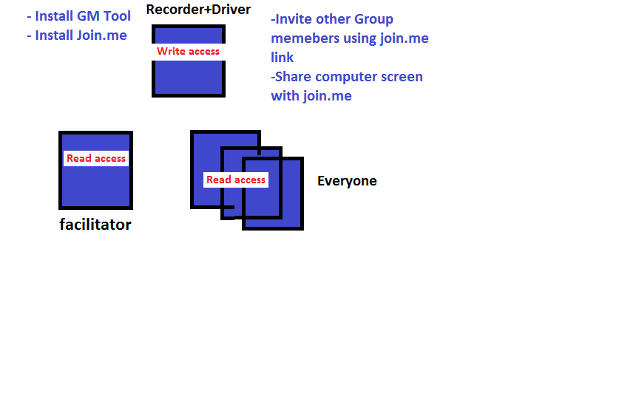

## Here’s What You Need to Set Up (if you do it on join.me):

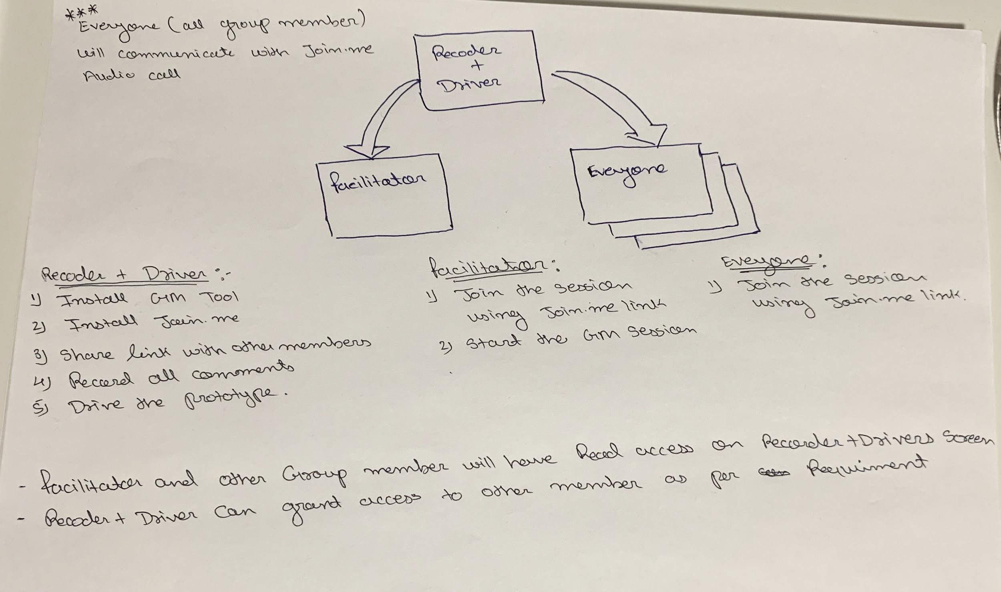

## Here’s What You Need to Set Up (if you do it on zoom):

We think you can accomplish the same thing on zoom, possibly even better than on join.me, since it also has things like break-out rooms and so on, but we’ve tested it only a little.

**This is a stub. Feel free to expand this.**